**The Respiratory System**

**Overall Function**: To carry _________ to and remove ____________ ______________ from the blood.

* The process of taking in oxygen and releasing carbon dioxide is called _____ _________.
* Gas exchange occurs in your ______________.

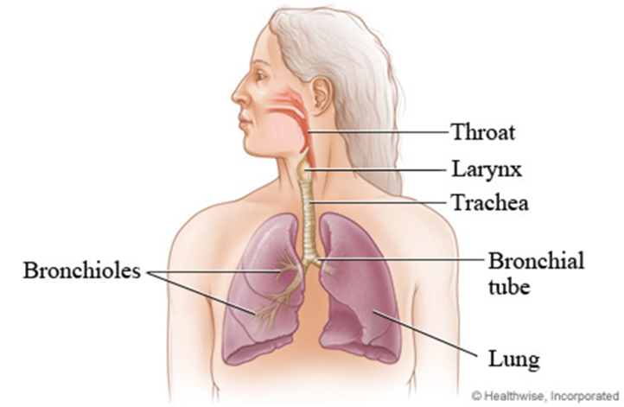

* Gas exchange occurs between the __________ and the __________________.
* Alveoli are tiny air sacs in the lungs. Alveoli are surrounded by a network of tiny blood vessels called _____________________.

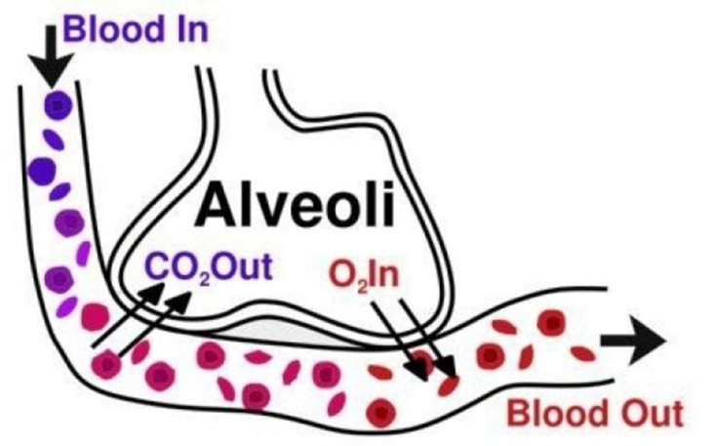

* Oxygen (O2) from the air you breathe in is taken up by the _______ __________ ______ flowing through the _________________.
* Carbon Dioxide (CO2) is released by the red blood cells and enters the alveoli. This air is then ______________.