Chemistry of Life Answers

1. Differentiate between an ionic and covalent bond. Provide an example for each.
• Ionic: occurs between metals and non-metals, e.g., NaCI
• Covalent: occurs between two non-metals; stronger than ionic, e.g., H20

2. Define the term electronegativity. What does a large electronegativity number represent?
• Electronegativity is a measure of an atom's ability to attract a shared electron pair when it is participating in a covalent bond.

3. Hydrogen bonds form between which atoms?
• Between an electropositive hydrogen and an electronegative N, 0 or F.

4. Define the terms hydrophobic and hydrophilic.
• Hydrophobic: a nonpolar molecule that does not dissolve in water ("water-hating").
• Hydrophilic: a polar molecule that dissolves in water ("water-loving").

5. Differentiate between an acid and a base.
• Acid: solutions with a pH less than 7; release hydrogen ions in solution; sour-tasting,
conducts electricity.
• Base: solutions with a pH greater than 7; accept hydrogen ions in solution &/or release hydroxide ions in solution; bitter tasting, conducts electricity and has a slippery feel.

6. Explain why functional groups are important.
• Involved in chemical reactions
• gives compounds their chemical properties
• makes organic compounds polar (except methyl)

7. Draw each of the following functional groups:
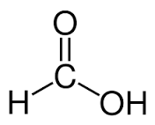
carbonyl (aldehyde) |  | Carboxyl
Carbonyl (ketone) | 0  II  -c- | hydroxyl | -OH
Amino |  | phosphate | 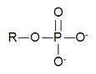

8. Which kind(s) of organic compounds are the following functional groups associated with?
Phosphate Phospholipids, nucleic acids, energy compounds (ATP)
Carboxyl amino acids, fatty acids
hydroxyl carbohydrates

9. How many functional groups can you identify in the compound below? Circle and identify each group. Three

NH2 -amino
COOH -carboxyl
SH -sulfhydryl

10. What is the name for the compound in question 9? Amino acid

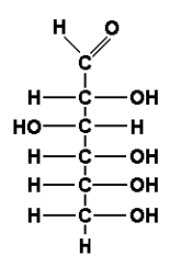
11. What functional groups can you identify in the compound below? Circle and label them and then name the compound.

Monosaccharide (C8H1208) carbohydrate

Aldehyde and several hydroxyl groups

12. What kind of organic compound is show below? What functional groups can you identify?
Circle and label one of them.
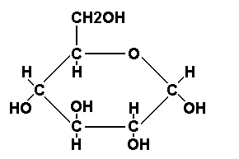

Monosaccharide- glucose (C₆H₁₂O₆)
Carbohydrate

Only hydroxyl groups

13. Two of the above compounds are being linked together in the diagram below to form what new compound? Complete the bond that joins these two compounds together. What
type of linkage connects these two compounds together?

A Disaccharide (maltose) -glycosidic linkage

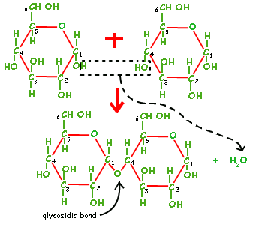

a) What are the products of this reaction?
Water plus a disaccharide (maltose)

b) What is the name given to this type of reaction?
Condensation reaction or dehydration synthesis.
14. Name four examples of polysaccharides and state their primary function.
Starch -energy storage in plants Cellulose- structural support in plants Glycogen - energy storage in animals
Chitin - structural support in fungi& exoskeleton of insects and crustaceans

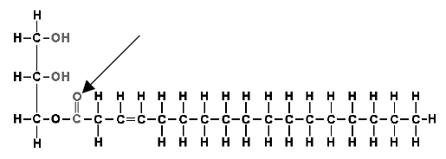
15. What functional groups are found in lipids, such as the one found below? Circle and identify each group.

Hydroxyl and carboxyl the hydroxyl groups are found in the glycerol backbone and the carboxyl is found on the fatty acid.

16. What is the name of the bond indicated by the arrow in the lipid above?
Ester bond

17. What type of fatty acid is shown in the lipid above?
Monounsaturated

18. How would a polyunsaturated fatty acid differ?
It would have several double bonds between the carbon atoms.

19. How would a saturated fatty acid differ?
There would be no double bonds between carbon atoms

20. If the lipid above was a triglyceride, how many fatty acids would be linked to the glycerol?
3

21. If the lipid above was a phospholipid, how many fatty acids would be linked to the glycerol and what additional group(s) would be present in the molecule?
A phosphate

22. What type of reaction would occur to link each fatty acid to the glycerol?
Condensation reaction or dehydration synthesis

23. List the different types of lipids and state each of their functions.
1. Phospholipids & sterols: structural support
2. Triglycerides: stored energy, cushioning, insulation, padding
3. Waxes: protection (e.g., waxy cuticle on leaves)
4. Lipid hormones & fat soluble vitamins: chemical regulators

24.When a person goes on a diet, stored lipids begin to be digested. What happens chemically when the lipids are digested?
They are catabolized (broken down) to fatty acids and glycerol, which can then be used for energy. Energy is released during catabolic reactions

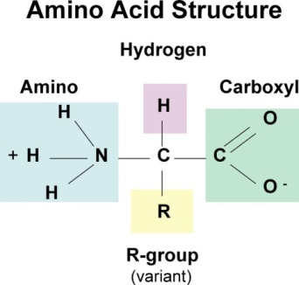

25. What type of compound is shown below?
Amino acids

27. Describe what would have to occur to link the two compounds together. What substance is removed (produced)?
A hydrogen from the amino group of one amino acid is removed; an OH from the carboxyl
of the second amino acid Is removed permitting a bond to form between the two amino acids. A molecule of water is removed

28. What Is the name of the bond that is formed between these two compounds?
Peptide bond

29. Use several functions of proteins.
1. structure- cell membranes, bone, cartilage, muscle
2. buffers
3. chemical regulation-enzymes, hormones
4. protection –bones antibodies, blood clotting
5. muscle contraction & movement

30. Explain what is meant by a protein's primary, secondary, tertiary and quaternary structure.
• Primary structure: sequence of amino acids that make upa polypeptide chain.
• Secondary structure: Hydrogen bonding that causes coils and folds in a polypeptide chain (e.g.• alpha helix,beta-pleated sheet).
• Tertiary structure: Supercoiling of a polypeptide due to the environment
• Quaternary structure: two or more polypeptide chains bond together to form a
functional protein.

31. What does a nucleotide consist of?
A pentose (5-carbon) sugar, a nitrogenous base and a phosphate group.

32. What are the five nitrogenous bases found in nucleic acids?
Adenine (A), guanine (G), thymine (T), cytosine (C), uracil (U)

33. Differentiate between DNA and RNA.
DNA: deoxyribonucleic acid; contains sugar deoxyribose; A, T, G & C bases; double helix (held by hydrogen bonds); antiparallel strands

RNA: ribonucleic acid; contains sugar ribose; A, U, G & C bases; single stranded helix

34. What type of bonds hold the sugar phosphate backbone of DNA & RNA together?
Phosphodiester

35. What type of bonds hold the nitrogenous bases of DNA together?
Hydrogen

36. What is ATP?

Adenosine triphosphate (another type of nucleotide): adenine + ribose + 3 phosphate groups. Used as an energy-transferring molecule.

